ESCAPE PLAN NOTES — PROPERTY OF INMATE #47
(DO NOT LET THE GUARDS SEE. OR THE PRIEST. ESPECIALLY NOT THE PRIEST.)

General Thoughts and Failed Plans
I’ve been here too long. Days blend together. I tried keeping track, but after Year 3 even the scratches on the wall started looking like teeth. Or maybe claws. Doesn’t matter.
Important rule:
Never try to escape on Laundry Rotation Day.
Too many guards around. (Except maybe Wedenig, who always hides in the staff lounge pretending to fix the coffee machine.)
Anyway…
Some guards rotate by day of week. They act like it’s random—but it’s not. Nothing here is random except the soup in the cafeteria. I wrote down who usually works which weekday somewhere. If you know today’s date, you know the weekday. If you know the weekday, you know the guard. The key to the first real door out is always in the guard’s locker of the guard working today.
They didn’t move things since ’23. They rarely move things since they’re too busy trying to guess who keeps changing the screen saver in the warden’s office.
I also once tried befriending Guard Ottowitz by complimenting her haircut. Turns out it was a wig. That plan failed quickly. Very quickly.
Escape attempts:
- “dig under the sink”
- “pretend to be dead and get carried outside” (DO NOT DO THAT AGAIN)
- “set fire to the kitchen” (turns out sprinklers work)
The final time I attempted to escape I discovered a torn sticky note with the last two of four digits of the door code. Lucky me. Or maybe it was just skill…

Guard Observations

Staff Members
Bachmann:
- Dog lover. Constantly mentions his dog “Bubbles”.
- Always checking that his dog gets enough water.
- Once wrote his code on a banana.
Lercher:
- Always joking about the “nice” number (don’t ask).
- I think his books are only decoration.
Ottowitz:
- Likes to watch herself in the mirror and loves symmetry.
- The only other living thing she looks after is her office plant.
- Keeps backup notes in a small box labeled “Recovery” (very dramatic).
Tscheinig:
- Fitness addict. Idealizes his favorite player CR7.
- Chaotic guy. Just throwing everything on his chairs.
- Once wrote his code on a gym towel. It washed off.
Wedenig:
- Has a crush on the chef. Always bringing her the same number of flowers.
- Likes to watch funny cat videos on his laptop.

Office Room Infos

Don’t mix up the offices. They all look the same but smell different. Wedenig’s smells like dirt and fresh flowers. Bachmann’s like wet dog. Tscheinig always keeps dirty sportswear around. Ottowitz’s office smells like feet. Lercher’s office is the only one with a calendar—nobody knows why.

Cell Wing
I’ve tried to piece together the guard patterns. Some of this is outdated; some is good; some is intentionally wrong so if these notes get confiscated, no one will believe any of it. Good luck figuring out which is which.

Guard Rotation Notes
 | Monday | Tuesday | Wednesday | Thursday | Friday
Cellblock | Tscheinig | Wedenig | Ottowitz | Lercher | Bachmann
Cafeteria | Bachmann | Lercher | Tscheinig | Ottowitz | Wedenig
Storage | Wedenig | Bachmann | Lercher | Tscheinig | Ottowitz
Laundry | Ottowitz | Tscheinig | Bachmann | Wedenig | Lercher
Yard | Lercher | Ottowitz | Wedenig | Bachmann | Tscheinig
They rotate randomly on weekends. Or take turns sleeping. Don’t rely on this.

Guard Check-in Sheet

Once I found an old check-in sheet. I like the color of the pen. I always knew that the guards are lazy. They even don’t carry their locker keys around but keep them hidden in their offices. Finally! With this list I have proof! Just look at Wedenig, always late! And Tscheining checks in early but goes running for one hour right after signing in.
Name | Time | Signature
Bachmann |  | 
Lercher | 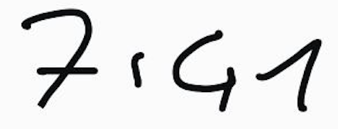 | 
Ottowitz | 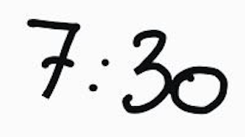 | 
Tscheinig |  | 
Wedenig | 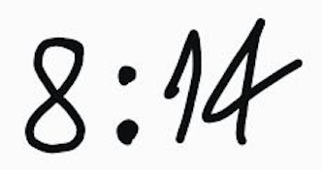 | 

Cafeteria & Kitchen
The kitchen is the easiest place to listen in on guard conversations because they think the sound of boiling goo hides their gossip. It doesn’t.
You’ll find tons of random sticky notes there. Most are useless reminders.
But some sticky notes are actually written by guards needing to remember door codes. They often tear off corners and stuff them in pockets. Sloppy handwriting everywhere.
It’s their own fault. The worst system ever. Every day one guard creates a new code based on what they personally like and distributes it to the others.

- “Buy more onions”
- “Order new mop”
- “Tell Tscheinig to wash his dirty cloths”

